MOUNTING THE BEARCAT/ UNIDEN BCD7T SCANNER IN A 2U PANEL WITH SPEAKER
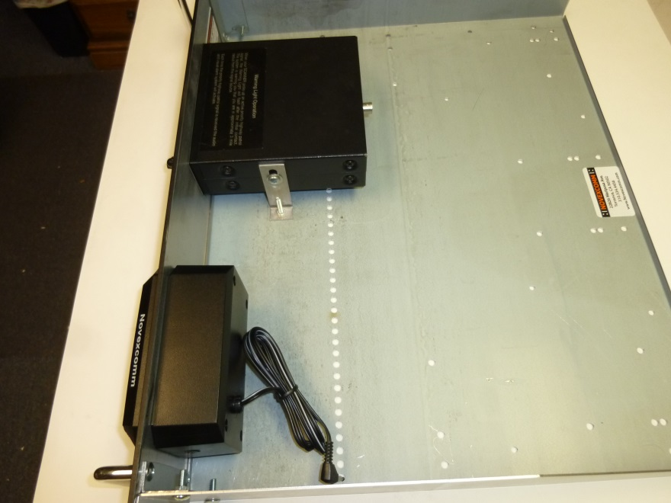 NOTE THE BNC ANTENNA CONNECTOR
